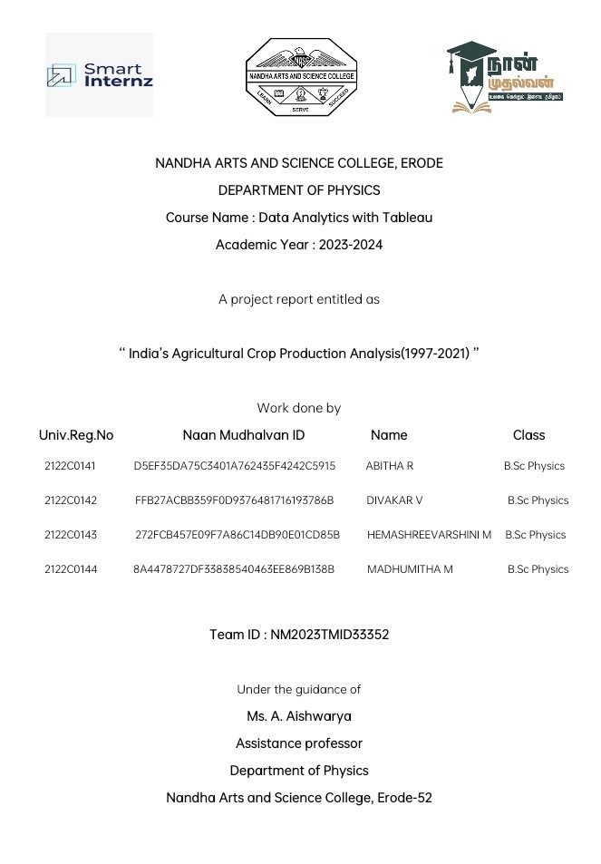

**INDEX**

|  |  |  |
| --- | --- | --- |
| **S. No** | **TITLE** | **PAGE No** |
| 1 | Introduction | 1 |
| 2 | Problem definition and design thinking | 3 |
| 3 | Result | 6 |
| 4 | Advantages and disadvantages | 15 |
| 5 | Application | 16 |
| 6 | Conclusion | 18 |
| 7 | Future scope | 19 |
| 8 | Appendix | 20 |

1

**India's Agriculture crop production analysis (1997-2021)**

**1.INTRODUCTION**

**1.1 Overview**

Agriculture, with its allied sectors, is unquestionably the largest livelihood provider in India, more so in the vast rural areas. It also contributes a significant figure to the Gross Domestic Product (GDP). Sustainable agriculture, in terms of food security, rural employment, and environmentally sustainable technologies such as soil conservation, sustainable natural resource management and biodiversity protection, are essential for holistic rural development. Indian agriculture and allied activities have witnessed a green revolution, a white revolution, a yellow revolution and a blue revolution.

This section provides the information on agriculture produces; machineries, research etc. Detailed information on the government policies, schemes, agriculture loans, market prices, animal husbandry, fisheries, horticulture, loans & credit, sericulture etc. is also available. In 2016, agriculture and allied sectors like animal husbandry, forestry and fisheries accounted for 17.5% of the GDP (gross domestic product) with about 41.49% of the workforce in 2020. India ranks first in the world with highest net cropped area followed by US and China. The economic contribution of agriculture to India's GDP is steadily declining with the country's broad-based economic growth. Still, agriculture is demographically the broadest economic sector and plays a significant role in the overall socio-economic fabric of India.

The total agriculture commodities export was US$3.50 billion in March - June 2020. India exported $38 billion worth of agricultural products in 2013, making it the seventh-largest agricultural exporter worldwide and the sixth largest net exporter.[7] Most of its agriculture exports serve developing and least developed nations.[7] Indian agricultural/horticultural and processed foods are exported to more than 120 countries, primarily to the Japan, Southeast Asia, SAARC countries, the European Union and the United States.

2

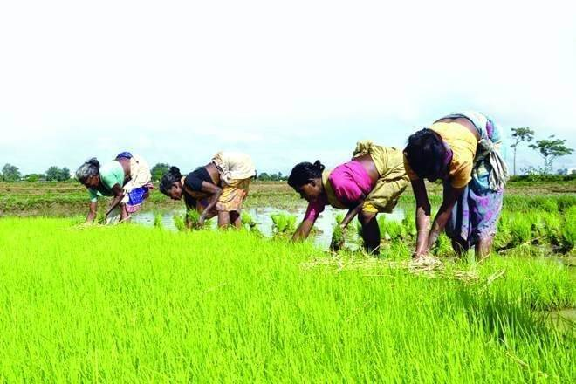

**1.2 Purpose**

Agriculture is the practice of cultivating natural resources to sustain human life and provide economic gain. It combines the creativity, imagination, and skill involved in planting crops and raising animals with modern production methods and new technologies. The Indian Economy is an Agro-Economy; the difficulty with such an agro economy is that the agriculture sector is highly dependent on the cycle of production, distribution, and consumption. Another problem with the Agro-economy is productivity. Currently, Indian Farmers produce 2.4 tonnes of rice per hectare of land, far behind its actual potential. On the other hand, China and Brazil produce 4.7 and 3.6 tonnes of rice per hectare. Despite so many disadvantages of the agriculture sector, it is still the most crucial sector for the Indian Economy. Agriculture provides employment opportunities to rural agricultural and non-agricultural labourers. It plays a significant role in international trade and import and export activities.

3

**2. PROBLEM DEFINITION AND DESIGN THINKING**

**2.1 Empathy map**

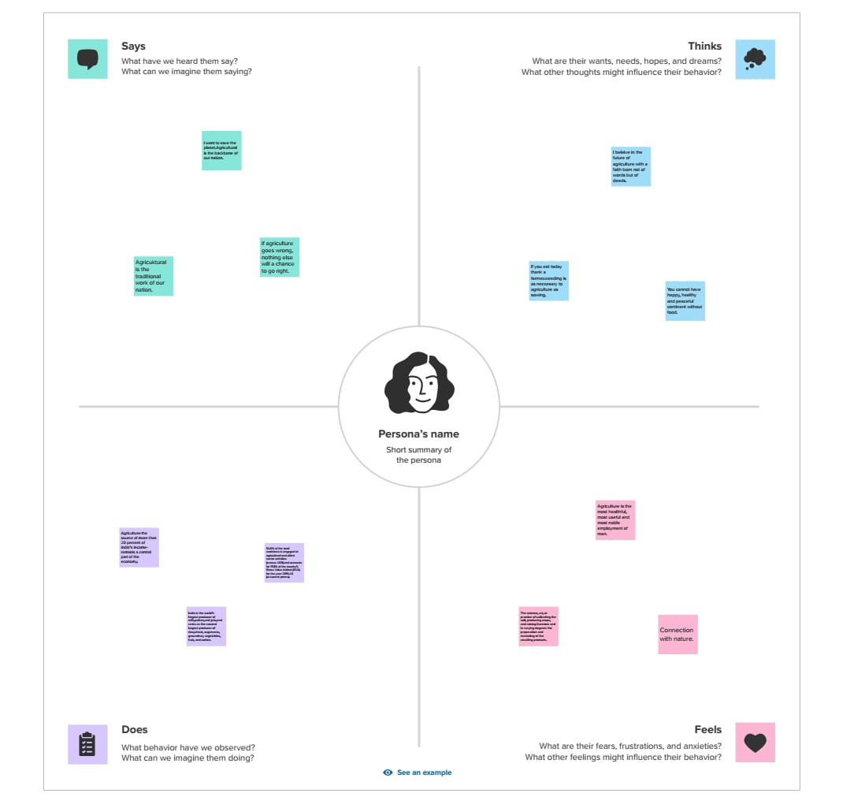

4

**2.2 Ideation & Brainstorming map**

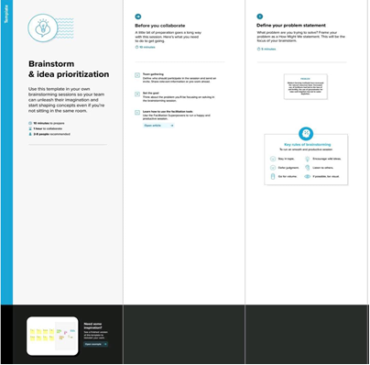

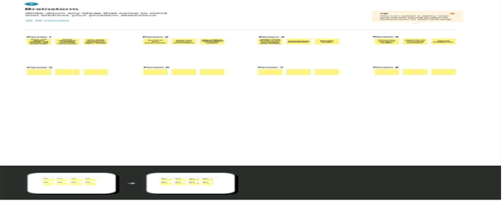

5

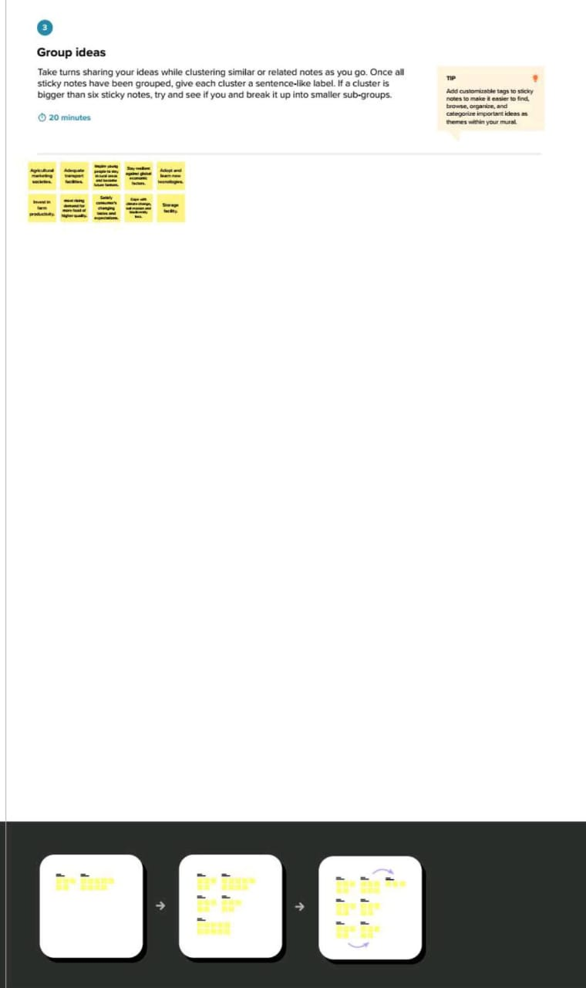

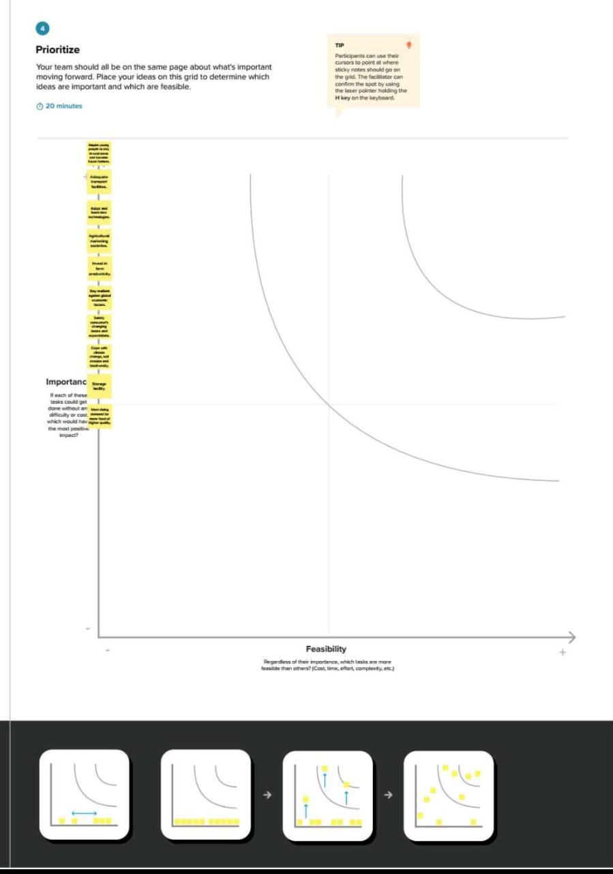

6

**3. RESULT**

**Dashboard 1**

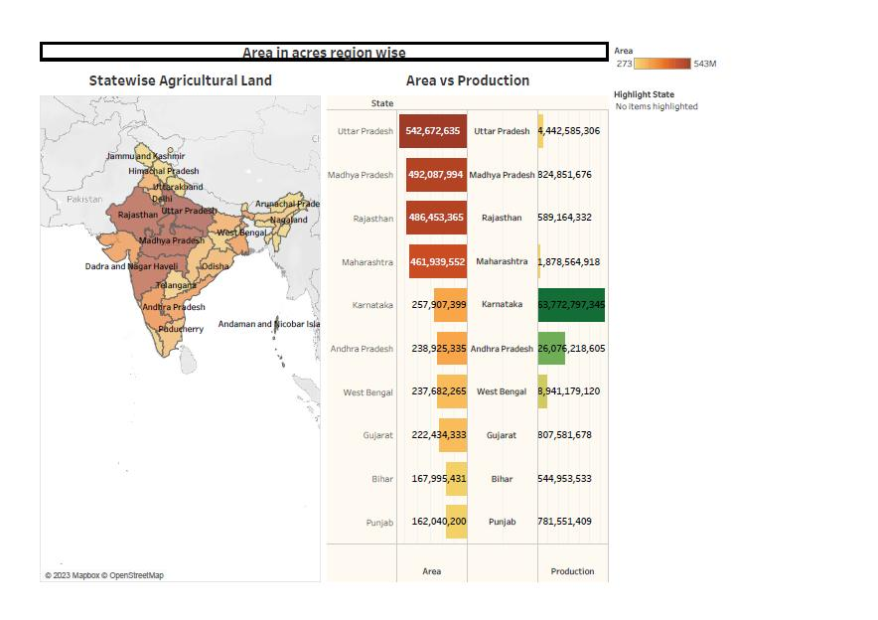

**Dashboard 2**

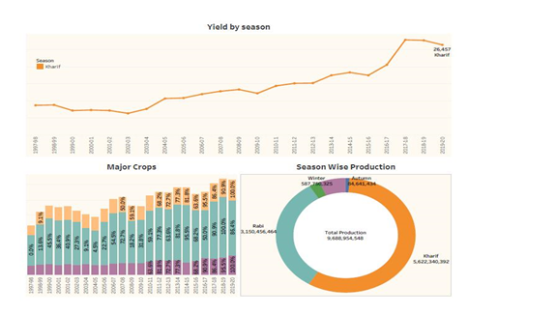

7

**Dashboard 3**

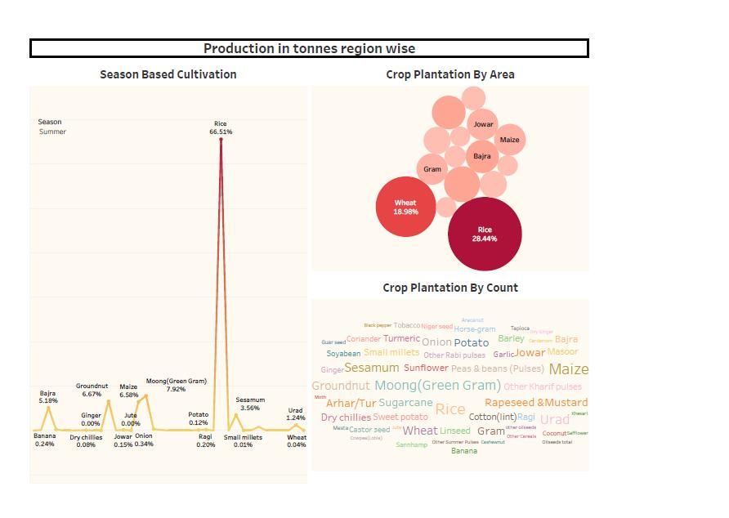

8

**STORY**

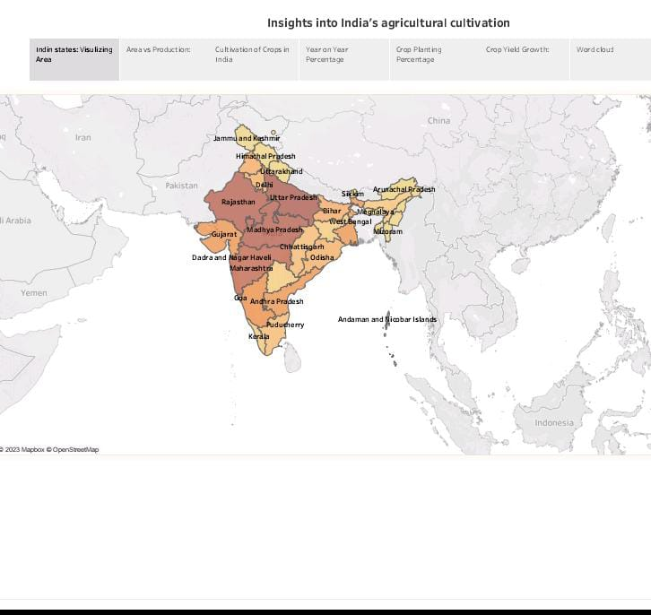

9

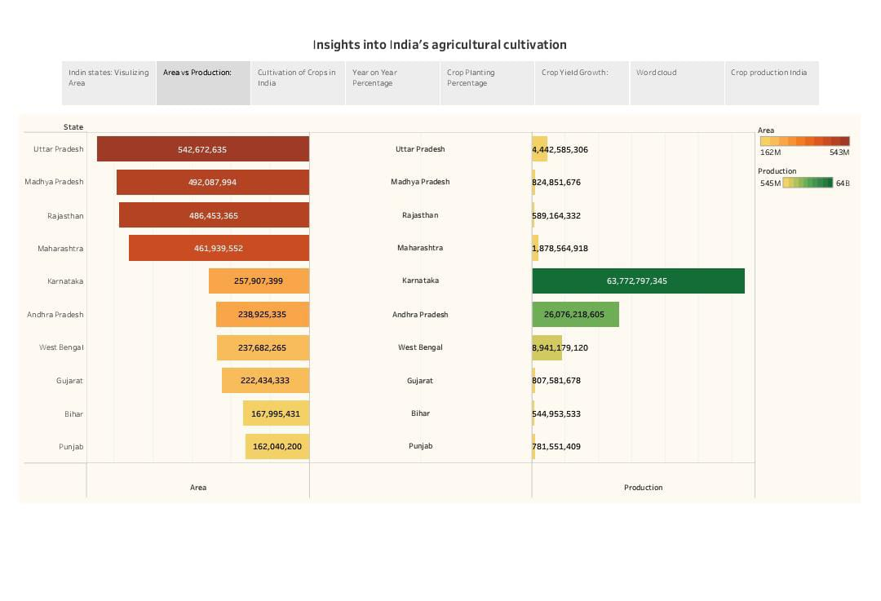

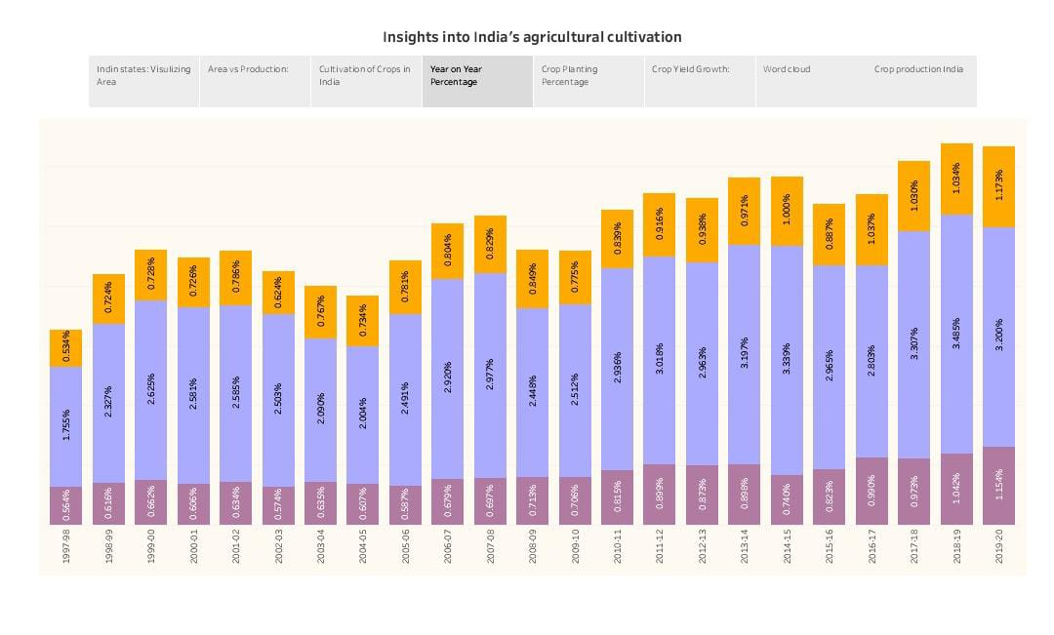

10

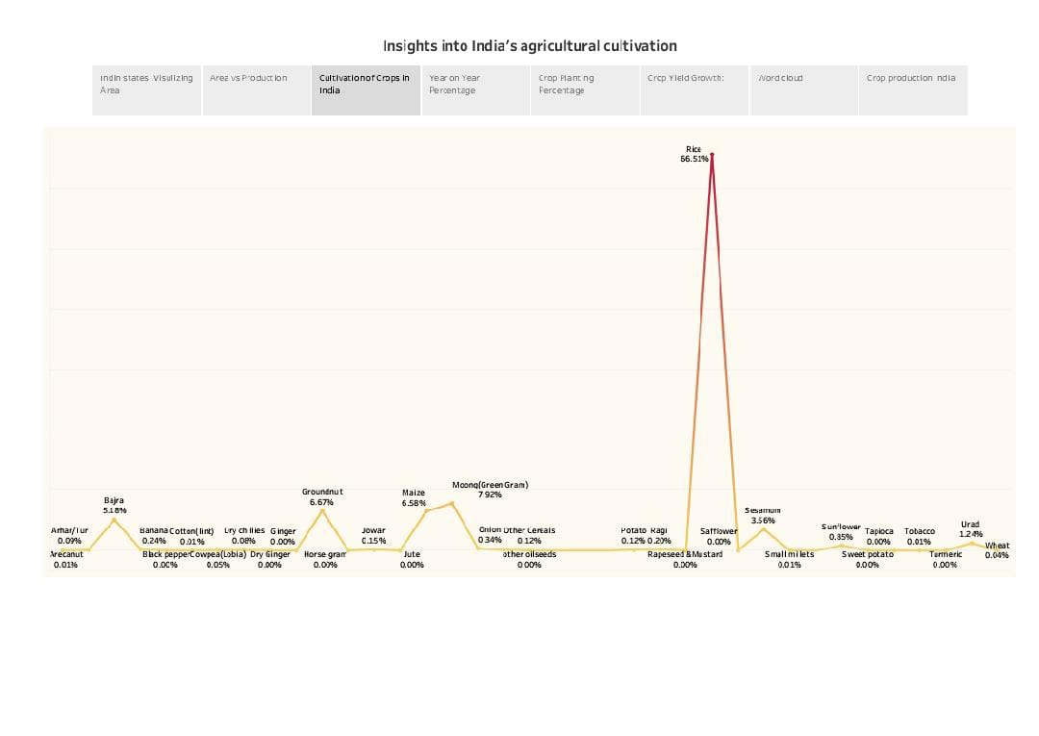

11

**Visualization**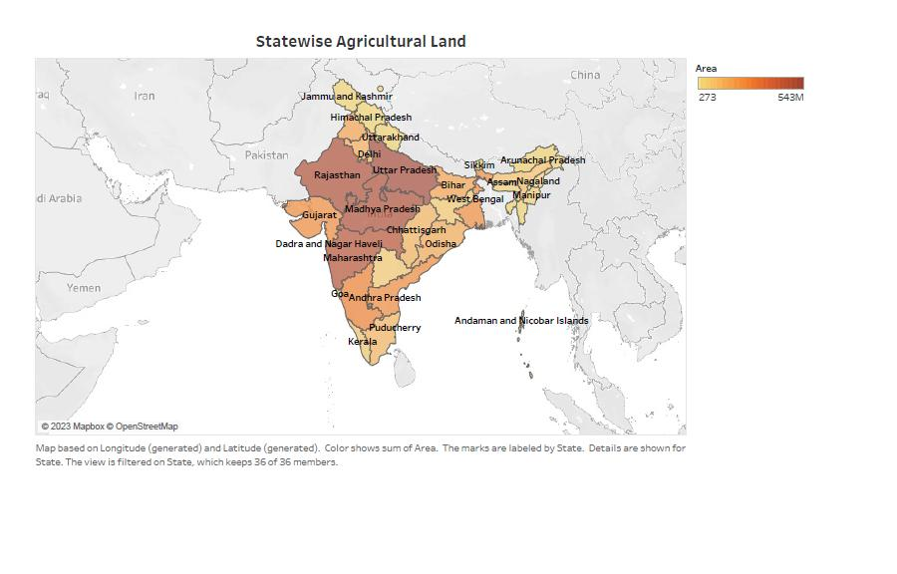

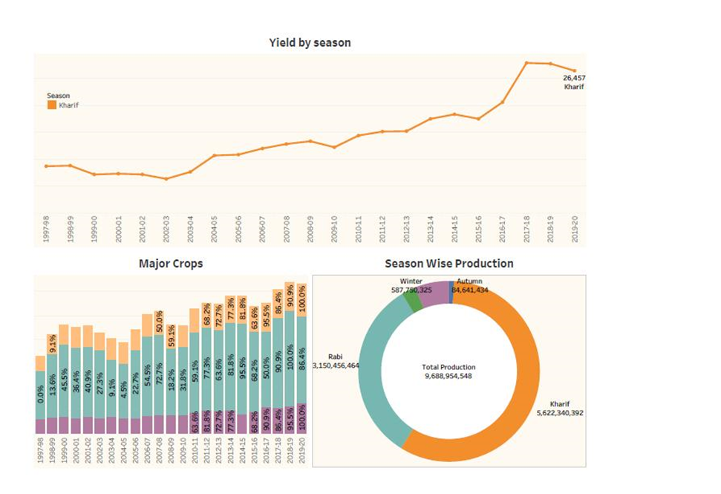

12

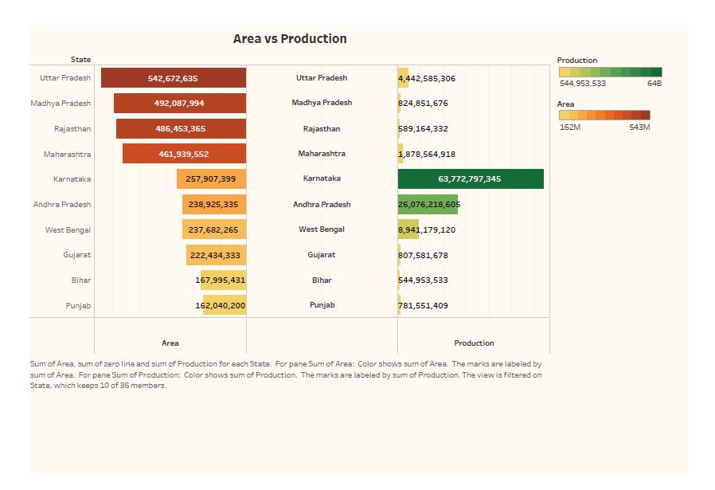

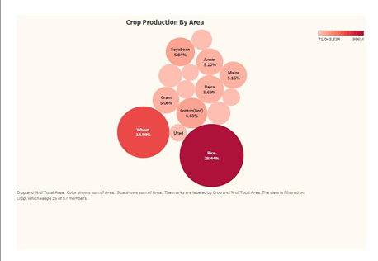

13

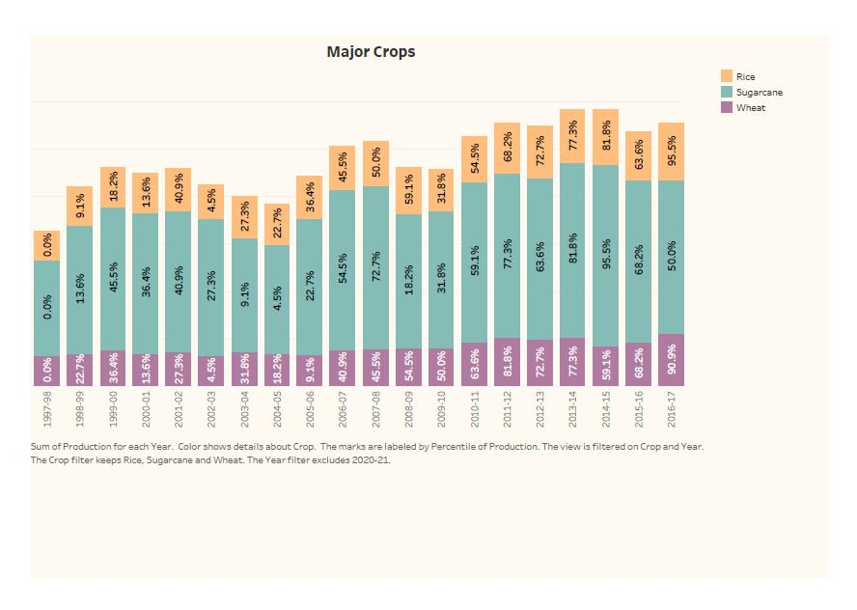

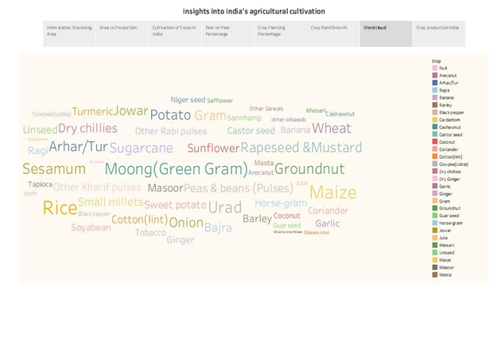

14

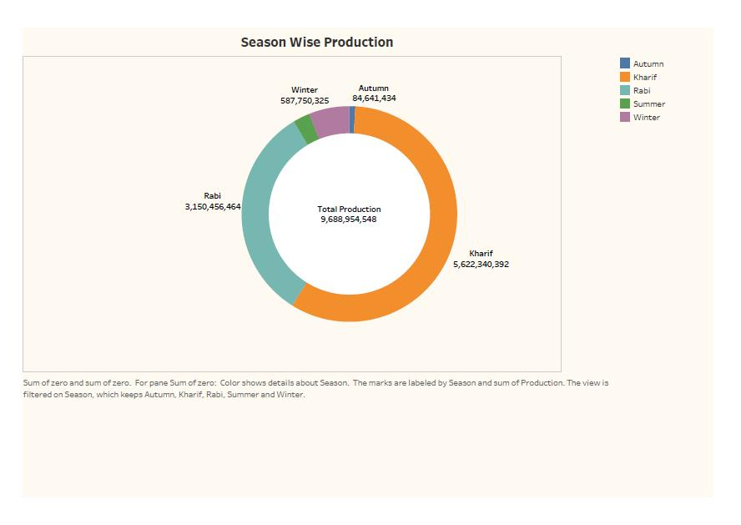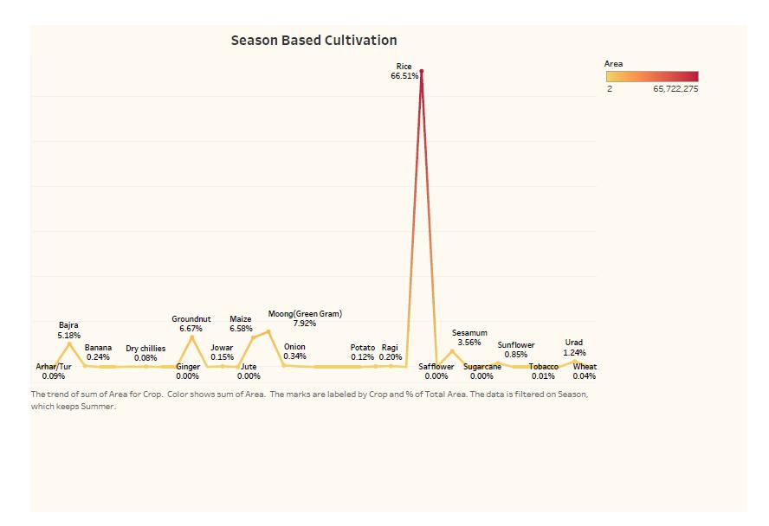

15

**ADVANTAGES AND DISADVANTAGES**

**ADVANTAGES**

Agriculture impacts society in many ways, including: supporting livelihoods through food, habitat, and jobs; providing raw materials for food and other products; and building strong economies through trade. Source: The Balance Small Business.

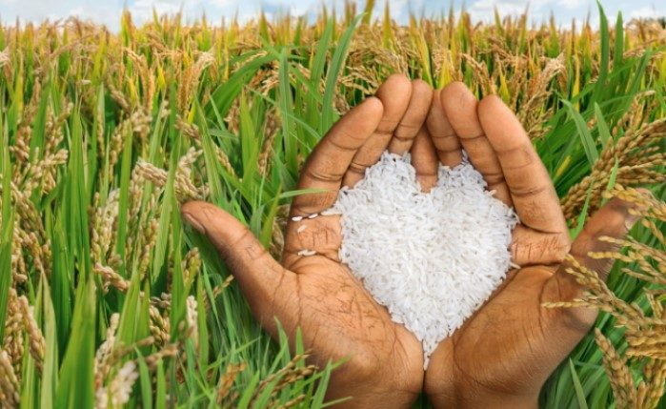

Economic contribution: Agriculture is a major contributor to the global economy. It provides employment to millions of people worldwide, especially in rural areas. Additionally, agriculture supports various industries, including food processing, transportation, and retail, which further boosts economic growth.

16

**DISADVANTAGES**

Deforestation. Intensive farming causes soil degradation and leads to the expansion of new lands ,Pest and weed resistance to chemicals,Soil degradation,Impact on natural habitats , Water pollution , Climate change.

Environmental degradation: Intensive agriculture can lead to soil erosion, deforestation, water pollution, and loss of biodiversity. Depletion of natural resources: Agriculture can lead to the depletion of natural resources such as water and soil, and can lead to land degradation and desertification.

**APPLICATIONS**

(i) cultivating, characterizing or modifying soil

(ii) producing, growing, improving, protecting, treating or modifying crops or forest products;

(iii) raising, harvesting, improving, protecting, treating or modifying livestock, poultry, fish or shellfish;

(iv) the preparation, marketing or treatment of products resulting from the activities described in (i)-(iii) above.

17

Agricultural Applications shall include applications involving the improvement or modification of soil, crops, livestock, poultry, fish or shellfish and their resulting products as they relate to human health, as well as foods from plants and animals designed or modified to enhance their health attributes, in each case for nutraceutical applications but not therapeutic applications in humans. Agricultural Applications shall also include agricultural applications relating to bacteria, fungi, and viruses, as well as pest organisms with respect to, and only to the extent of, such bacteria, fungi, viruses or pest organisms' interaction with soil, plants, livestock, poultry.

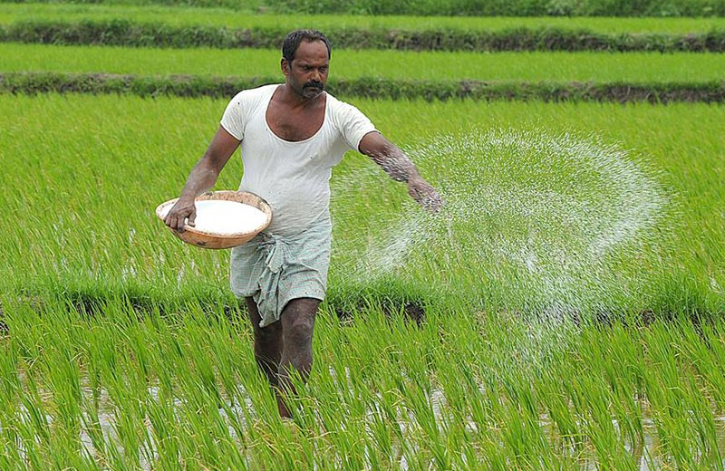

18

**CONCLUSION**

India's agricultural sector is still very important to the Indian economy, although its share of the economy has decreased over the past 50 years.

Agriculture is the single largest producing sector of economy since it comprises about 30% of the country's GDP and employing around 60% of the total labor force.

The performance of this sector has an overwhelming Impact on major macroeconomic objectives like employment generation, poverty alleviation, human resources development and food security.

Meeting the nation's food requirements remain the key- objective of the government and in recent years there has been substantial increase in grain production.

19

**FUTURE SCOPE**

A student pursuing BSc Agriculture course will study a wide variety of subjects including agronomy, soil sciences, horticulture (fruit science & vegetable), plant breeding and genetics, entomology, plant pathology, animal sciences, extension education, plant biochemistry, agriculture economics, basics of biotechnology, etc. The syllabus is as per the guidelines of ICAR (Indian Council of Agriculture Research) and is designed to train students to understand ways of improving the crop production in a sustainable manner and to provide overall knowledge related to agriculture and related disciplines.

20

**APPENDIX**

Github link:

<https://github.com/madheshsanthi/Indian-Agriculture>

Dashboard 1:

[https://public.tableau.com/app/profile/hemashreevarshini.m/viz/Areainacresregionwise_16971748790000/Dashboard1?publish=yes#WelcomeQuestionnaire](https://public.tableau.com/app/profile/hemashreevarshini.m/viz/Areainacresregionwise_16971748790000/Dashboard1?publish=yes#WelcomeQuestionnaire" \o "https://public.tableau.com/app/profile/hemashreevarshini.m/viz/Areainacresregionwise_16971748790000/Dashboard1?publish=yes#WelcomeQuestionnaire)

Dashboard 2:

[https://public.tableau.com/app/profile/hemashreevarshini.m/viz/productionintonnesregionwise/Dashboard1?publish=yes#WelcomeQuestionnaire](https://public.tableau.com/app/profile/hemashreevarshini.m/viz/productionintonnesregionwise/Dashboard1?publish=yes#WelcomeQuestionnaire" \o "https://public.tableau.com/app/profile/hemashreevarshini.m/viz/productionintonnesregionwise/Dashboard1?publish=yes#WelcomeQuestionnaire)

Dashboard 3:

<https://public.tableau.com/app/profile/hemashreevarshini.m/viz/story1_16971731527700/Dashboard2?publish=yes#WelcomeQuestionnaire>

Visualization 1:

<https://public.tableau.com/app/profile/hemashreevarshini.m/viz/story1_16971731527700/Sheet1?publish=yes#WelcomeQuestionnaire>

Visualization 2:

<https://public.tableau.com/app/profile/hemashreevarshini.m/viz/story1_16971731527700/Sheet2?publish=yes#WelcomeQuestionnaire>

Visualization 3:

<https://public.tableau.com/app/profile/hemashreevarshini.m/viz/story1_16971731527700/Sheet3?publish=yes#WelcomeQuestionnaire>

Visualization 4:

<https://public.tableau.com/app/profile/hemashreevarshini.m/viz/story1_16971731527700/Sheet4?publish=yes#WelcomeQuestionnaire>

Visualization 5:

<https://public.tableau.com/app/profile/hemashreevarshini.m/viz/story1_16971731527700/Sheet5?publish=yes#WelcomeQuestionnaire>

Visualization 6:

<https://public.tableau.com/app/profile/hemashreevarshini.m/viz/story1_16971731527700/Sheet6?publish=yes#WelcomeQuestionnaire>

Visualization 7:

<https://public.tableau.com/app/profile/hemashreevarshini.m/viz/story1_16971731527700/Sheet7?publish=yes#WelcomeQuestionnaire>

Visualization 8:

<https://public.tableau.com/app/profile/hemashreevarshini.m/viz/story1_16971731527700/Sheet8?publish=yes#WelcomeQuestionnaire>

Story:

<https://public.tableau.com/app/profile/hemashreevarshini.m/viz/story1_16971731527700/Story1?publish=yes#WelcomeQuestionnaire>

Video Demonstration:

<https://drive.google.com/file/d/1DzCH5gq7-Nkazukf9yfT3qKfc5SrhX2k/view?usp=drivesdk>